Appendix A - Description of test areas at Andøya
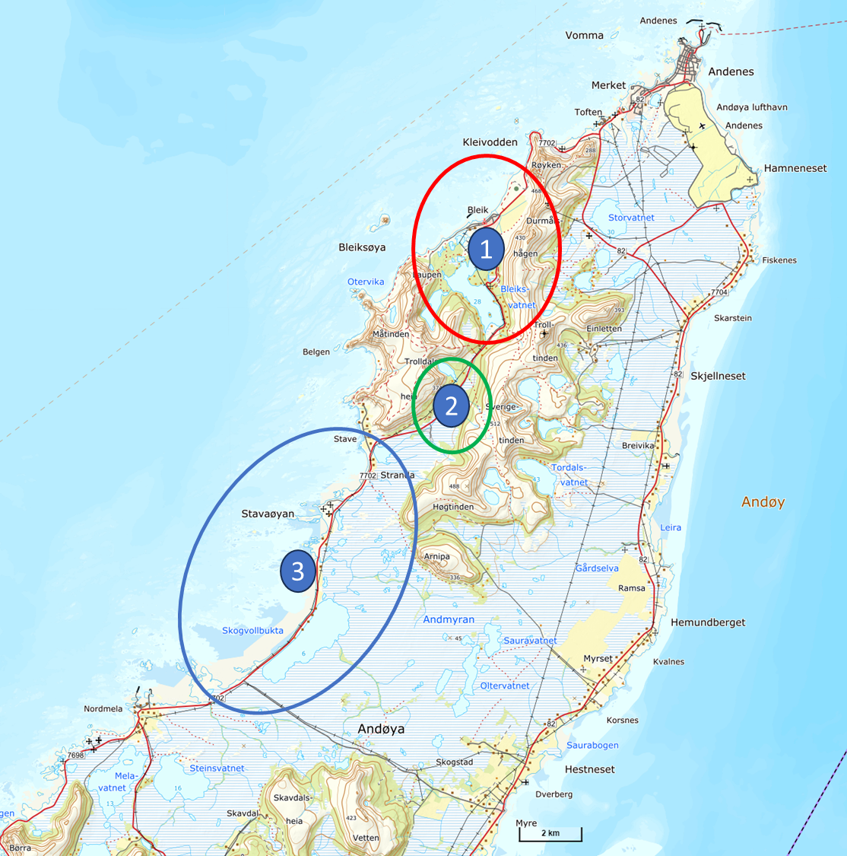

RED = Official Test Area 1
Green = Official Test Area 2
Blue = Official Test Area 3

Survey points
Notice: Geodetic reference frame for plane coordinates is EUREF89.
Differences between EUREF89 and WGS84, see Appendix H.
Seven significant decimal digits for latitude and longitude will ensure cm-precision.

Table 1: Coordinates for Jammertest 2026 (Physical height = heights in The Norwegian NN2000 height system)
 | Point-ID |  | UTM33-North |  | UTM33-East |  | Physical  height |  | Latitude |  | Longitude |  | Ellipsoidal  height |  | Mark
 | ORIG |  | 7679455,50 |  | 536952,70 |  | 31,33 |  | 69,2225166 |  | 15,9334241 |  | 67,22 |  | Origo Site2
 | SENDER |  | 7685781,10 |  | 539724,98 |  | 361,49 |  | 69,2788429 |  | 16,0060623 |  | 397,28 |  | FFI Jammer
 | RX-1 |  | 7685948,78 |  | 539904,09 |  | 315,76 |  | 69,2803199 |  | 16,0106675 |  | 351,54 |  | Antenna FFI
 | RX-2 |  | 7685779,70 |  | 540153,98 |  | 322,14 |  | 69,2787668 |  | 16,0169243 |  | 357,90 |  | Antenna FFI
 | REFANT |  | 7685462,32 |  | 538282,87 |  | 3,12 |  | 69,2761930 |  | 15,9694187 |  | 38,97 |  | Antenna
 | SAMF |  | 7685417,69 |  | 538272,09 |  | 3,46 |  | 69,2757944 |  | 15,9691279 |  | 39,31 |  | Lift antenna
 | R1 |  | 7685386,74 |  | 538234,19 |  | 3,86 |  | 69,2755222 |  | 15,9681560 |  | 39,71 |  | Corner antenna rig
 | R2 |  | 7685384,16 |  | 538236,05 |  | 3,75 |  | 69,2754988 |  | 15,9682020 |  | 39,60 |  | Corner antenna rig
 | R3 |  | 7685382,32 |  | 538233,40 |  | 3,74 |  | 69,2754826 |  | 15,9681343 |  | 39,59 |  | Corner antenna rig
 | R4 |  | 7685384,89 |  | 538231,65 |  | 3,81 |  | 69,2755059 |  | 15,9680910 |  | 39,66 |  | Corner antenna rig
 | MEAC1 |  | 7680854,71 |  | 537417,51 |  | 62,71 |  | 69,2349991 |  | 15,9457087 |  | 98,58 |  | Antenna FOI
 | MEAC2 |  | 7680851,60 |  | 537421,29 |  | 62,70 |  | 69,2349707 |  | 15,9458028 |  | 98,57 |  | Antenna FOI
 | A50 |  | 7679505,41 |  | 536955,45 |  | 29,97 |  | 69,2229637 |  | 15,9335127 |  | 65,85 |  | Tree stick top
 | A100 |  | 7679555,31 |  | 536958,19 |  | 29,85 |  | 69,2234108 |  | 15,9336011 |  | 65,74 |  | Tree stick top
 | A150 |  | 7679605,22 |  | 536960,94 |  | 29,89 |  | 69,2238580 |  | 15,9336898 |  | 65,77 |  | Tree stick top
 | B50 |  | 7679428,17 |  | 536994,55 |  | 30,19 |  | 69,2222658 |  | 15,9344705 |  | 66,07 |  | Tree stick top
 | B100 |  | 7679400,84 |  | 537036,39 |  | 31,34 |  | 69,2220150 |  | 15,9355167 |  | 67,22 |  | Tree stick top
 | B150 |  | 7679373,51 |  | 537078,24 |  | 33,54 |  | 69,2217642 |  | 15,9365630 |  | 69,42 |  | Tree stick top
 | C50 |  | 7679432,93 |  | 536908,11 |  | 29,17 |  | 69,2223203 |  | 15,9322893 |  | 65,05 |  | Tree stick top
 | C100 |  | 7679410,35 |  | 536863,52 |  | 28,49 |  | 69,2221239 |  | 15,9311544 |  | 64,38 |  | Tree stick top
 | C150 |  | 7679387,78 |  | 536818,92 |  | 28,16 |  | 69,2219276 |  | 15,9300194 |  | 64,05 |  | Tree stick top
 | D50 |  | 7679478,07 |  | 536997,29 |  | 30,90 |  | 69,2227129 |  | 15,9345589 |  | 66,79 |  | Tree stick top
 | D100 |  | 7679500,65 |  | 537041,89 |  | 31,95 |  | 69,2229092 |  | 15,9356941 |  | 67,83 |  | Tree stick top
 | D150 |  | 7679523,22 |  | 537086,48 |  | 34,86 |  | 69,2231055 |  | 15,9368289 |  | 70,74 |  | Tree stick top
 | E50 |  | 7679405,60 |  | 536949,95 |  | 30,14 |  | 69,2220694 |  | 15,9333354 |  | 66,02 |  | Tree stick top
 | E100 |  | 7679355,69 |  | 536947,21 |  | 29,25 |  | 69,2216223 |  | 15,9332470 |  | 65,13 |  | Tree stick top
 | E150 |  | 7679305,78 |  | 536944,46 |  | 29,96 |  | 69,2211752 |  | 15,9331584 |  | 65,85 |  | Tree stick top
 | F50 |  | 7679482,83 |  | 536910,85 |  | 29,02 |  | 69,2227673 |  | 15,9323776 |  | 64,91 |  | Tree stick top
 | F100 |  | 7679510,16 |  | 536869,01 |  | 28,22 |  | 69,2230181 |  | 15,9313314 |  | 64,11 |  | Tree stick top
 | F150 |  | 7679537,49 |  | 536827,16 |  | 27,81 |  | 69,2232689 |  | 15,9302849 |  | 63,70 |  | Tree stick top
 | N500 |  | 7679955,50 |  | 536952,70 |  | 30,00 |  | 69,2270000 |  | 15,9336165 |  | 65,89 |  | «Help point»
 | 301 |  | 7670668,62 |  | 530198,75 |  | 8,41 |  | 69,1445605 |  | 15,7600882 |  | 44,52 |  | Painted mark
 | 302 |  | 7670680,37 |  | 530212,30 |  | 8,49 |  | 69,1446644 |  | 15,7604330 |  | 44,61 |  | Painted mark
 | 303 |  | 7677529,28 |  | 534164,53 |  | 8,17 |  | 69,2056106 |  | 15,8623208 |  | 44,16 |  | Painted mark
 | 304 |  | 7677547,58 |  | 534161,78 |  | 8,09 |  | 69,2057750 |  | 15,8622578 |  | 44,08 |  | Painted mark
 | 305 |  | 7678211,00 |  | 534007,45 |  | 6,02 |  | 69,2117434 |  | 15,8585975 |  | 42,02 |  | Painted mark
 | 306 |  | 7678203,81 |  | 534010,27 |  | 6,11 |  | 69,2116786 |  | 15,8586663 |  | 42,10 |  | Painted mark
 | JAM-S3A |  | 7678283,66 |  | 533997,48 |  | 5,33 |  | 69,2123962 |  | 15,8583718 |  | 41,33 |  | Painted mark
 | JAM-S3B |  | 7678283,26 |  | 533994,81 |  | 5,38 |  | 69,2123930 |  | 15,8583042 |  | 41,37 |  | Painted mark
 | 307 |  | 7679014,60 |  | 534010,65 |  | 6,43 |  | 69,2189489 |  | 15,8589629 |  | 42,43 |  | Painted mark
 | 308 |  | 7679027,13 |  | 534017,55 |  | 6,21 |  | 69,2190604 |  | 15,8591415 |  | 42,21 |  | Painted mark
 | 309 |  | 7677843,92 |  | 534179,92 |  | 6,87 |  | 69,2084301 |  | 15,8628211 |  | 42,86 |  | Painted mark
 | 310 |  | 7677829,74 |  | 534174,75 |  | 6,96 |  | 69,2083036 |  | 15,8626854 |  | 42,95 |  | Painted mark
 | AS |  | 7687584,32 |  | 540587,21 |  | 7,91 |  | 69,2948831 |  | 16,0286613 |  | 43,66 |  | Antenna
E_R1 |  | 7685393,59 |  | 538262,01 |  | 6,51 |  | 69,2755797 |  | 15,9688632 |  | 42,36 |  | Ericsson
E_R5 |  | 7685394,71 |  | 538263,62 |  | 6,50 |  | 69,2755894 |  | 15,9689043 |  | 42,35 |  | Ericsson
E_L5 |  | 7685393,89 |  | 538264,16 |  | 6,50 |  | 69,2755820 |  | 15,9689175 |  | 42,35 |  | Ericsson
E_L1 |  | 7685392,77 |  | 538262,63 |  | 6,50 |  | 69,2755722 |  | 15,9688784 |  | 42,35 |  | Ericsson
Description of Test Area 1
Overview maps of survey points
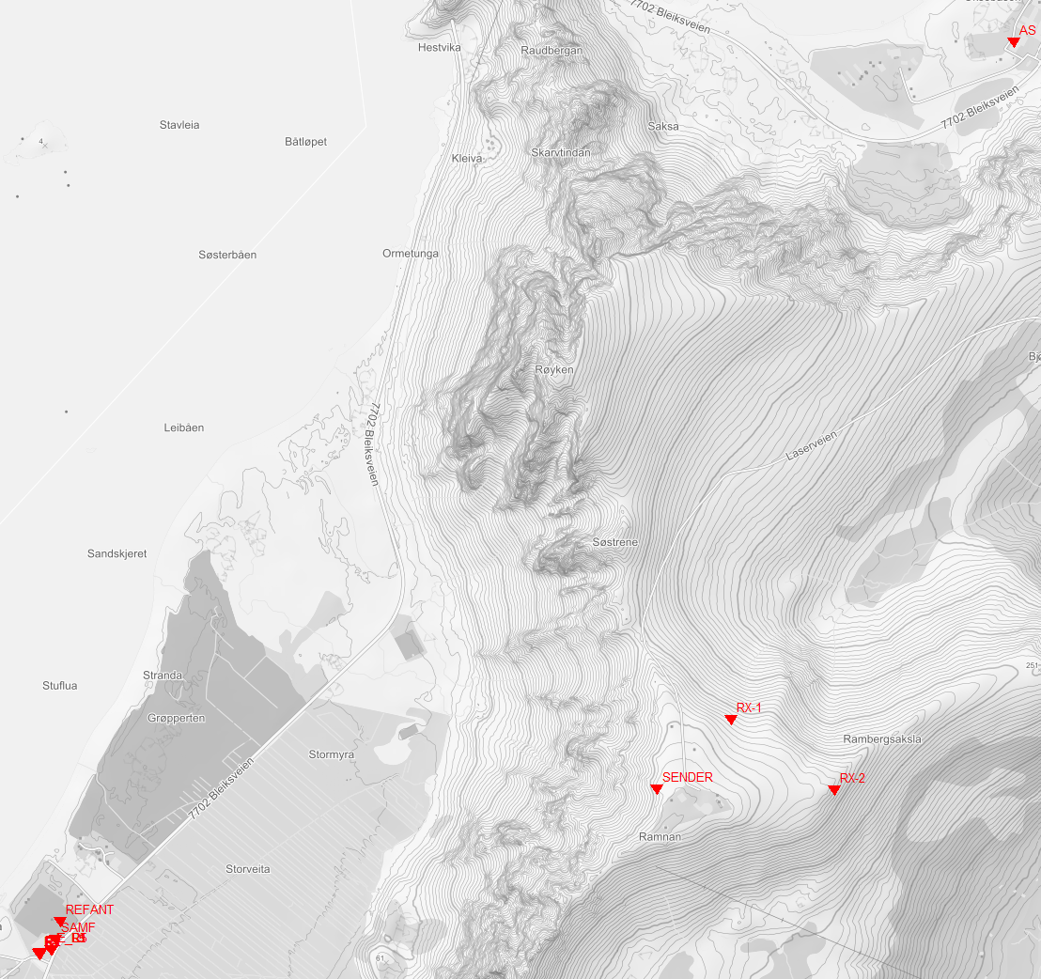
Scale 1:15000
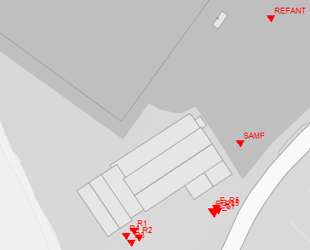
Scale 1:2000 More detailed view of surveyed points outside Bleik samfunnshus.

Description of Test Area 2
Test Area 2 is the parking area at the end of a dirt road. (Position N 69.2225°, Ø 15.9335°).
Most of the testing will be conducted at the parking or the surrounding area.
The setup is based around known positions, distances and controlled RF power levels
for the tests.

Barracks and parking plan 2026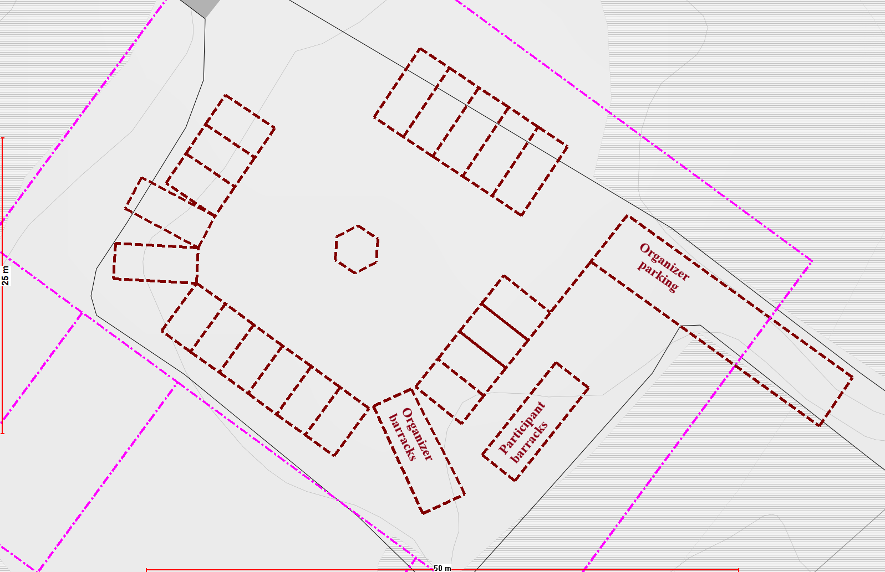
Figure 1: Barracks and parking plan 2026

Points Bauktuva parking area
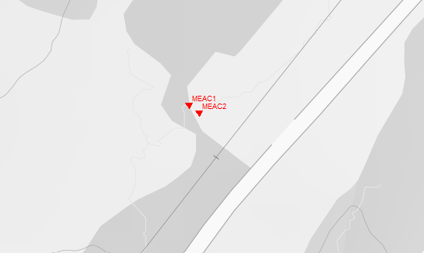
Scale 1:2000 Points by the barrack

Drone areas 2026

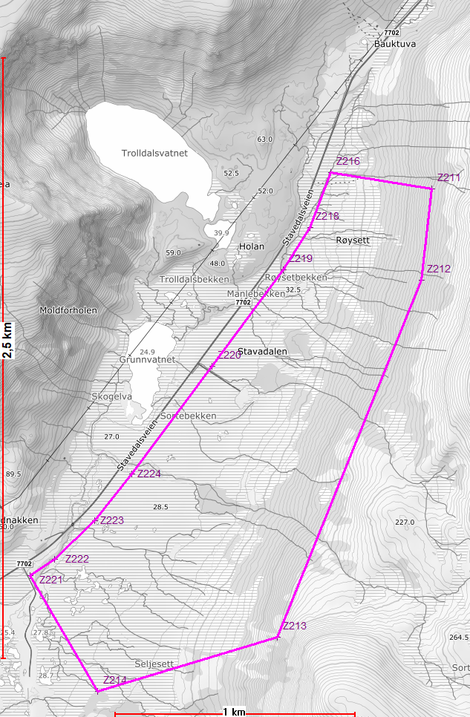
Flight zone
Figure 2: Drone area boundary

Jammer and drone markers 2026
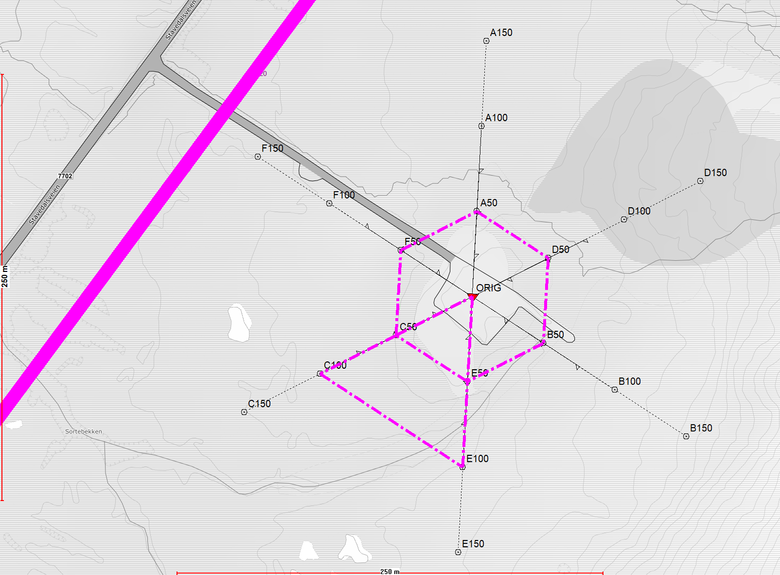
No flight zone
Take off
and landing
Operator
zone
Figure 3 Test Area 2, directions for where we place the jammers and several new directions (2026) that will work as visual markers from the air as “drone waypoints”.

The test setup at location 2
A, B and C axis are positions used for placement of jammers, or spoofing equipment, as shown in figure 3. A, B and C axis is separated 120 degrees apart. Points will be marked with “wood sticks” (trelekter).
D, E and F axis are continuations of C, A and B axis. They will be marked with drone waypoints visual from the air.
D, E and F- axis will have black and white drone markers, which should be visible at 100 meters above ground level.

Example: drone marker/ visual waypoint. (Dimensions 50 cm x 50 cm)

Fiducial marks added to drone markers for Test Area 2.
Axis marked with color and distance marked with squares.
Red = D - direction
Blue = E - direction
Green = F - direction
1 square = 50 meters
2 squares = 100 meters
3 squares = 150 meters

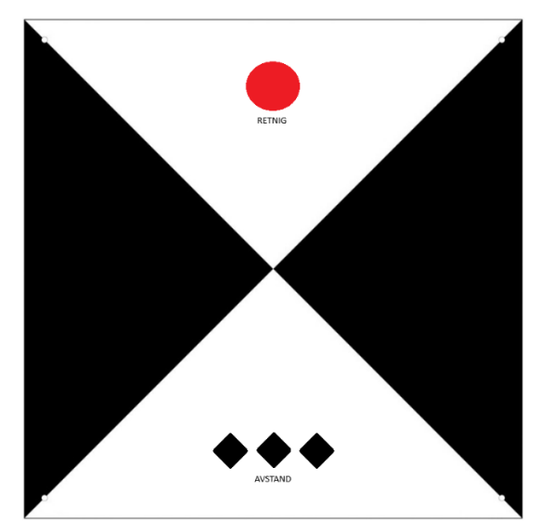
Example: D – direction @ 150 meters.

Description of motorcade route(s) on Andøya, Test Area 3
The start is as Stave community house (69.212187 North ,15.858559 East), the small jammers can be used the intersection between county road 7702 and communal road “Oklveien” (69.14409 North, 15.75847 East). The figure below shows the stretch that can be used for the motorcade (Red line).
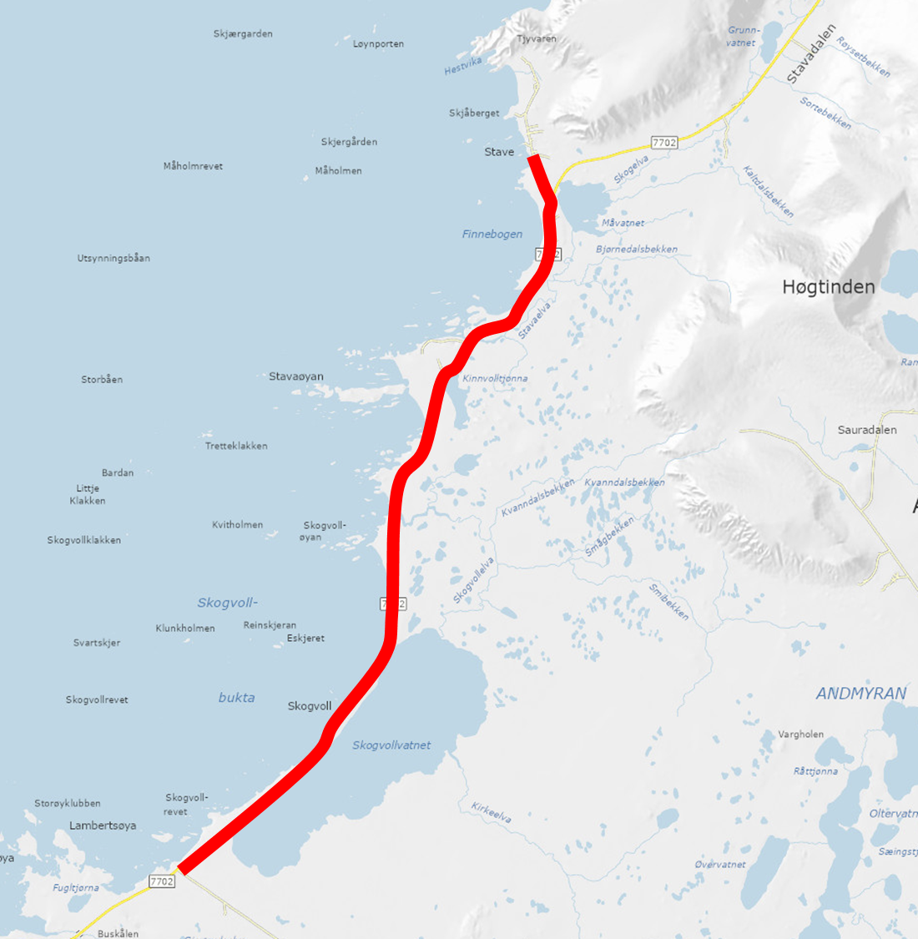

The road is quite narrow 5.1 meters with a speed limit of 80 km/h. The traffic volume is low with about 1000 vehicles per day. For some tests where reduced speed is need there will be a NPRA vehicle in front and at the back of motorcade. Communication to the vehicles will be via FM radio.

Calibration Control Marks
In a straight, open road section, three pairs of control marks (301-310) will be painted in center of the dotted white line at the right-hand side. The marks will be positioned so that vehicles can align with them as follows:
- The front right wheel is placed directly on the painted mark.
- The rear right wheel is aligned with the center of the white line.
This arrangement provides a precise and repeatable reference for the forward right wheel position relative to the vehicle’s facing direction.
The coordinates of the control marks will be averaged from several time independent RTK-measurements and distributed in Appendix A Table 1. These marks are intended for calibrating on-board GNSS and inertial navigation equipment against a known reference point.

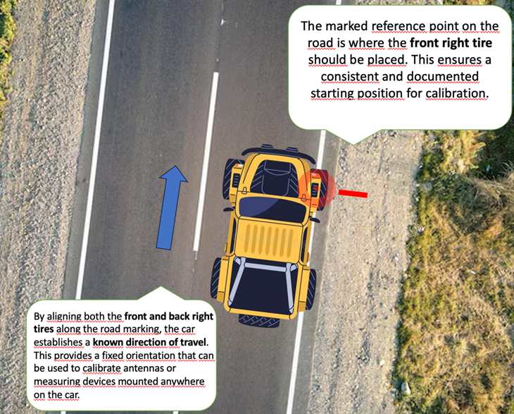

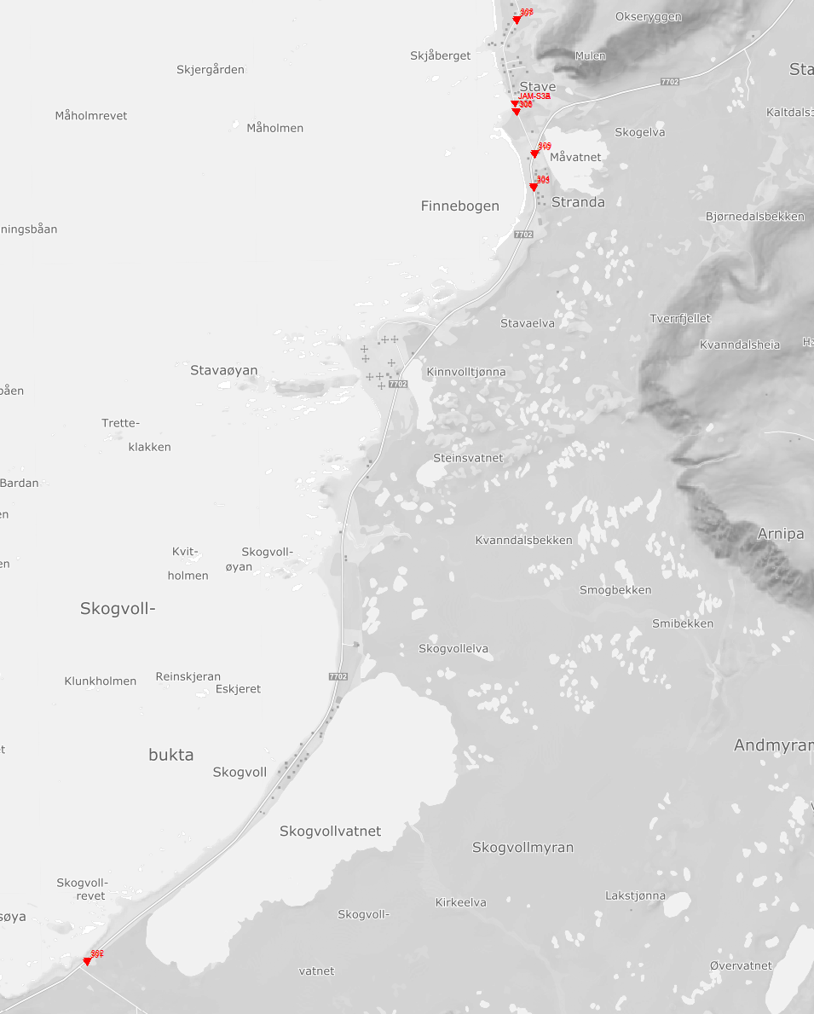
Scale 1:50000
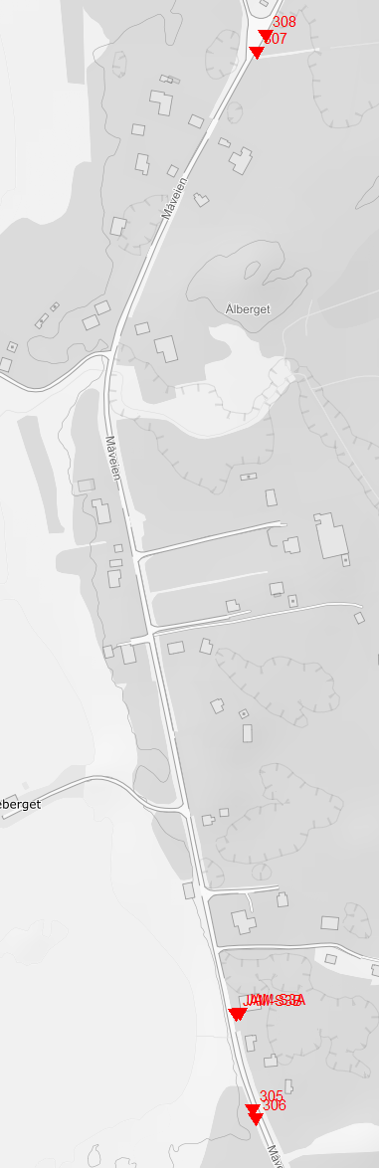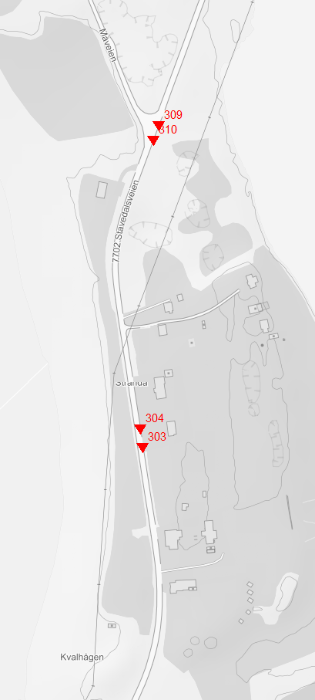
Scale 1:5000

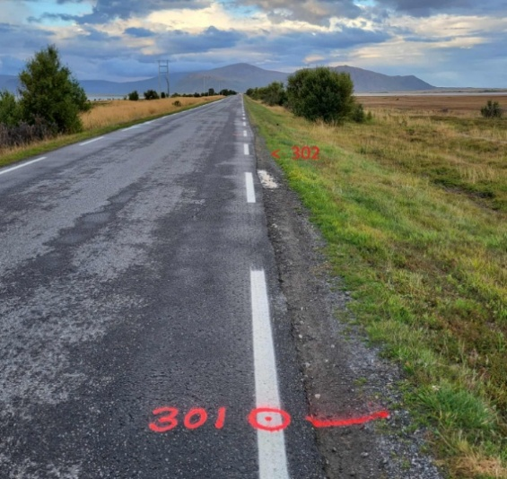
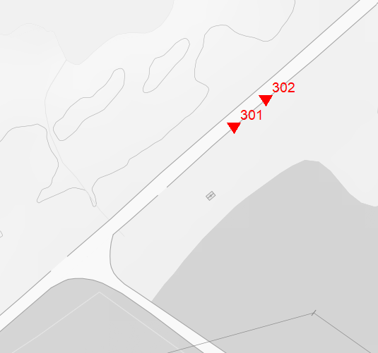
Scale 1:2000 Example, one pair of calibration points

